**ECE3051 – Analog and Digital Signal Processing, Fall Semester 2022-2023**

**ELA DA – 1, Slot: L25-L26**

**By: Jonathan Rufus Samuel (20BCT0332) Date: 21.8.2022**

__________________________________________________________________________________

**ELA DA 1 – DOS: 21.08.2022**

**Task - 1: GENERATION OF ELEMENTARY SIGNALS AND SYSTEM ANALYSIS**

**Q1) Generate the elementary signals that are employed for characterization of random signals. Also, generate a sinusoidal signal and subject the same to the following basic signal processing operations. a. Time Shifting / Delaying (TD) b. Folding / Reflection (FD) c. Verify, whether TD[FD]=FD[TD] d. Convolution e. Correlation Illustrate the above operations with relevant waveforms.**

**CODE:**

%Task - 1: GENERATION OF ELEMENTARY SIGNALS AND SYSTEM ANALYSIS

%Name: Jonathan Rufus Samuel (20BCT0332)

%Course: ECE3051 - ELA

%SubTask 1 - Generate the elementary signals that are employed for characterization of random

%signals. Also, generate a sinusoidal signal and subject the same to the following basic

%signal processing operations

%a. Time Shifting / Delaying (TD)

%b. Folding / Reflection (FD)

%c. Verify, whether TD[FD]=FD[TD]

%d. Convolution

%e. Correlation

%Illustrate the above operations with relevant waveforms.

%Elementary Functions:

%Zer0 Function

a = zeros(1 ,5);

b = a;

subplot(331),stem(b);

title('Zeros Function');

xlabel('Time');

ylabel('Magnitude');

grid;

%Ones Function

a = ones(1 ,5);

b = a;

subplot(332),stem(b);

title('Ones Function');

xlabel('Time');

ylabel('Magnitude');

grid;

%Impulse Function

a = zeros(1 ,4);

b = [a,1,a];

subplot(333),stem(b);

title('Impulse Function');

xlabel('time');

ylabel('Magnitude');

grid;

%Unit Step Function

a = zeros(1 , 4);

b = ones(1, 4);

c = [a,1,b];

t = (-1:0.01:5)';

% Start with all zeros:

unitstep = zeros(size(t));

% But make everything corresponding to t>=1 one:

unitstep(t>=0) = 1;

plot(t,unitstep,'b','linewidth',3)

% Repeat, with everything shifted to the right by 1 unit:

unitstep2 = zeros(size(t));

unitstep2(t>=2) = 1;

hold on

plot(t,unitstep2,'r:','linewidth',2)

subplot(334),stem(c);

title('Unit Step Function');

xlabel('time');

ylabel('Magnitude');

grid;

%Sine Function

a = 0:15:360;

b = sind(a);

subplot(335),stem(b);

title('Sine Function');

xlabel('time');

ylabel('Magnitude');

grid;

%Cosine Function

a = 0:15:360;

b = cosd(a);

subplot(336),stem(b);

title('Cosine Function');

xlabel('time');

ylabel('Magnitude');

grid;

%Exponential Signal

a = 1:20;

b = exp(a);

subplot(337),stem(b); %plot(b)

title('Exponential Function');

xlabel('time');

ylabel('Magnitude');

grid;

%Ramp Function

a = 1:10;

b = a;

subplot(338),stem(b);

title('Ramp Function');

xlabel('time');

ylabel('Magnitude');

grid;

%Parabolic Signal

a = linspace(-5,5,10);

b = 0.5*a.^2;

subplot(339),stem(a,b);

title('Parabolic Function');

xlabel('time');

ylabel('Magnitude');

grid;

%Generate a sinusoidal signal and subject the same to the following basic

a = 0:15:360;

b = sind(a);

subplot(331),stem(b);

title('Base Sinusoidal Function');

xlabel('time');

ylabel('Magnitude');

grid;

%signal processing operations:

%a. Time Shifting / Delaying (TD)

a = 0:15:360;

b = sind(a+30);

subplot(332),stem(b);

title('Time Delayed Sinusoidal Function');

xlabel('time');

ylabel('Magnitude');

grid;

%b. Folding / Reflection (FD)

a = 0:15:360;

b = sind(-a);

subplot(333),stem(b);

title('Folded Sinusoidal Function');

xlabel('time');

ylabel('Magnitude');

grid;

%c. Verify, whether TD[FD]=FD[TD]

a = 0:15:360;

x1 = sind(-sind(a+30));

y1 = sind(sind(-a-30));

subplot(211),stem(x1);

title('FD[TD] Function');

xlabel('time');

ylabel('Magnitude');

grid;

subplot(212),stem(y1);

title('TD[FD] Function');

xlabel('time');

ylabel('Magnitude');

grid;

%d. Convolution

Fs = 10000;

Ts = 1/Fs;

fc = 1000;

Tc = 1/fc;

t = 0:Ts:Tc;

% LTI impulse response h(t) = exp(-1000*t)

h = exp(-1000*t);

% angular frequency w = 2*pi*fc

w = 2*pi*fc;

% the signal x(t) = sin(wc*t)

x = sin(w*t);

% convolution of x(t) and h(t)

y = conv(x,h,'same');

subplot(3, 1, 1);

plot(t, h, 'LineWidth', 2);

grid on;

xlabel('t');

ylabel('h');

subplot(3, 1, 2);

plot(t, x, 'LineWidth', 2)

grid on;

xlabel('t');

ylabel('x');

subplot(3, 1, 3);

plot(t, y, 'LineWidth', 2)

grid on;

hold on

stem(t,y)

xlabel('t');

ylabel('y = x**h');

%e. Correlation

a = 0:15:360;

x = sind(a+30);

y = sind(-a);

R = corrcoef(x,y);

disp("The Result is: ");

disp(R);

**OUTPUT:**

>> %Elementary Functions:

%Zer0 Function

a = zeros(1 ,5);

b = a;

subplot(331),stem(b);

title('Zeros Function');

xlabel('Time');

ylabel('Magnitude');

grid;

%Ones Function

a = ones(1 ,5);

b = a;

subplot(332),stem(b);

title('Ones Function');

xlabel('Time');

ylabel('Magnitude');

grid;

%Impulse Function

a = zeros(1 ,4);

b = [a,1,a];

subplot(333),stem(b);

title('Impulse Function');

xlabel('time');

ylabel('Magnitude');

grid;

%Unit Step Function

a = zeros(1 , 4);

b = ones(1, 4);

c = [a,1,b];

t = (-1:0.01:5)';

% Start with all zeros:

unitstep = zeros(size(t));

% But make everything corresponding to t>=1 one:

unitstep(t>=0) = 1;

plot(t,unitstep,'b','linewidth',3)

% Repeat, with everything shifted to the right by 1 unit:

unitstep2 = zeros(size(t));

unitstep2(t>=2) = 1;

hold on

plot(t,unitstep2,'r:','linewidth',2)

subplot(334),stem(c);

title('Unit Step Function');

xlabel('time');

ylabel('Magnitude');

grid;

%Sine Function

a = 0:15:360;

b = sind(a);

subplot(335),stem(b);

title('Sine Function');

xlabel('time');

ylabel('Magnitude');

grid;

%Cosine Function

a = 0:15:360;

b = cosd(a);

subplot(336),stem(b);

title('Cosine Function');

xlabel('time');

ylabel('Magnitude');

grid;

%Exponential Signal

a = 1:20;

b = exp(a);

subplot(337),stem(b); %plot(b)

title('Exponential Function');

xlabel('time');

ylabel('Magnitude');

grid;

%Ramp Function

a = 1:10;

b = a;

subplot(338),stem(b);

title('Ramp Function');

xlabel('time');

ylabel('Magnitude');

grid;

%Parabolic Signal

a = linspace(-5,5,10);

b = 0.5*a.^2;

subplot(339),stem(a,b);

title('Parabolic Function');

xlabel('time');

ylabel('Magnitude');

grid;

>> %Generate a sinusoidal signal and subject the same to the following basic

a = 0:15:360;

b = sind(a);

subplot(331),stem(b);

title('Base Sinusoidal Function');

xlabel('time');

ylabel('Magnitude');

grid;

%signal processing operations:

%a. Time Shifting / Delaying (TD)

a = 0:15:360;

b = sind(a+30);

subplot(332),stem(b);

title('Time Delayed Sinusoidal Function');

xlabel('time');

ylabel('Magnitude');

grid;

%b. Folding / Reflection (FD)

a = 0:15:360;

b = sind(-a);

subplot(333),stem(b);

title('Folded Sinusoidal Function');

xlabel('time');

ylabel('Magnitude');

grid;

>> %Generate a sinusoidal signal and subject the same to the following basic

a = 0:15:360;

b = sind(a);

subplot(311),stem(b);

title('Base Sinusoidal Function');

xlabel('time');

ylabel('Magnitude');

grid;

%signal processing operations:

%a. Time Shifting / Delaying (TD)

a = 0:15:360;

b = sind(a+30);

subplot(312),stem(b);

title('Time Delayed Sinusoidal Function');

xlabel('time');

ylabel('Magnitude');

grid;

%b. Folding / Reflection (FD)

a = 0:15:360;

b = sind(-a);

subplot(313),stem(b);

title('Folded Sinusoidal Function');

xlabel('time');

ylabel('Magnitude');

grid;

>> %c. Verify, whether TD[FD]=FD[TD]

a = 0:15:360;

x1 = sind(-sind(a+30));

y1 = sind(sind(-a-30));

subplot(211),stem(x1);

title('FD[TD] Function');

xlabel('time');

ylabel('Magnitude');

grid;

subplot(212),stem(y1);

title('TD[FD] Function');

xlabel('time');

ylabel('Magnitude');

grid;

>> %d. Convolution

Fs = 10000;

Ts = 1/Fs;

fc = 1000;

Tc = 1/fc;

t = 0:Ts:Tc;

% LTI impulse response h(t) = exp(-1000*t)

h = exp(-1000*t);

% angular frequency w = 2*pi*fc

w = 2*pi*fc;

% the signal x(t) = sin(wc*t)

x = sin(w*t);

% convolution of x(t) and h(t)

y = conv(x,h,'same');

subplot(3, 1, 1);

plot(t, h, 'LineWidth', 2);

grid on;

xlabel('t');

ylabel('h');

subplot(3, 1, 2);

plot(t, x, 'LineWidth', 2)

grid on;

xlabel('t');

ylabel('x');

subplot(3, 1, 3);

plot(t, y, 'LineWidth', 2)

grid on;

hold on

stem(t,y)

xlabel('t');

ylabel('y = x**h');

%e. Correlation

a = 0:15:360;

x = sind(a+30);

y = sind(-a);

R = corrcoef(x,y);

disp("The Result is: ");

disp(R);

The Result is:

1.0000 -0.8575

-0.8575 1.0000

>>

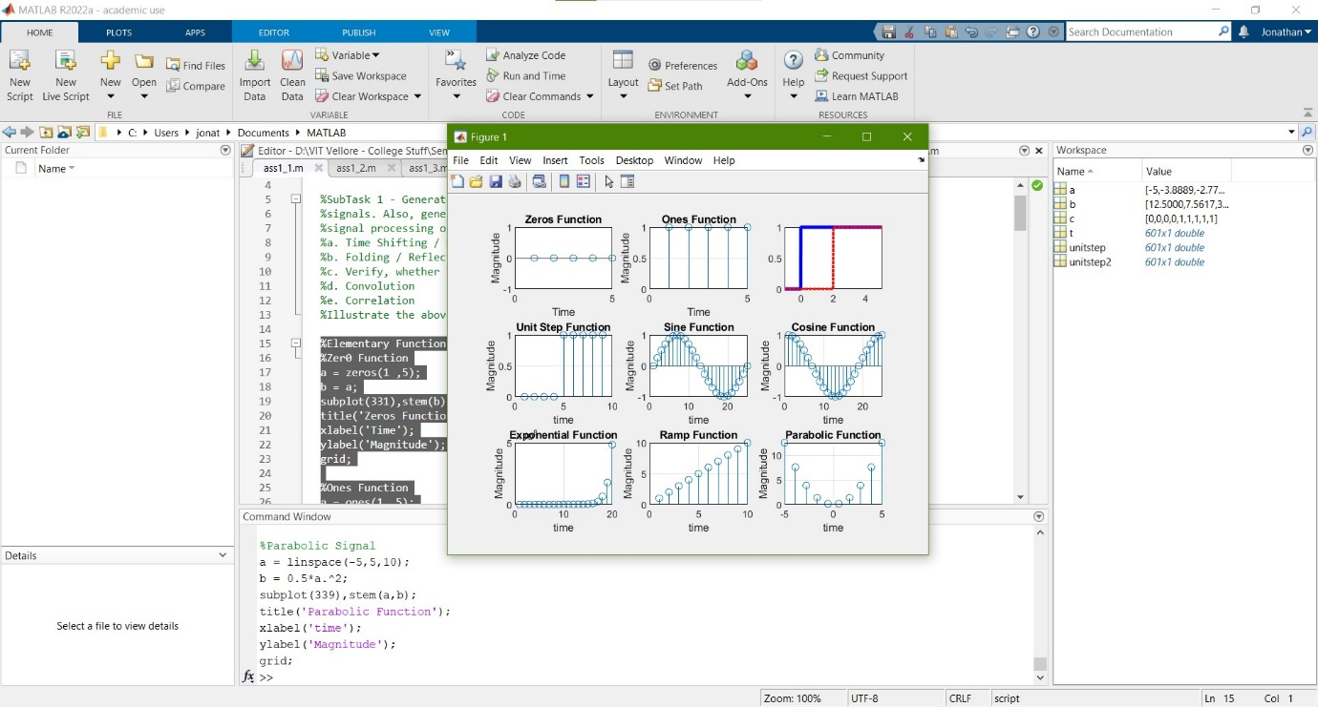

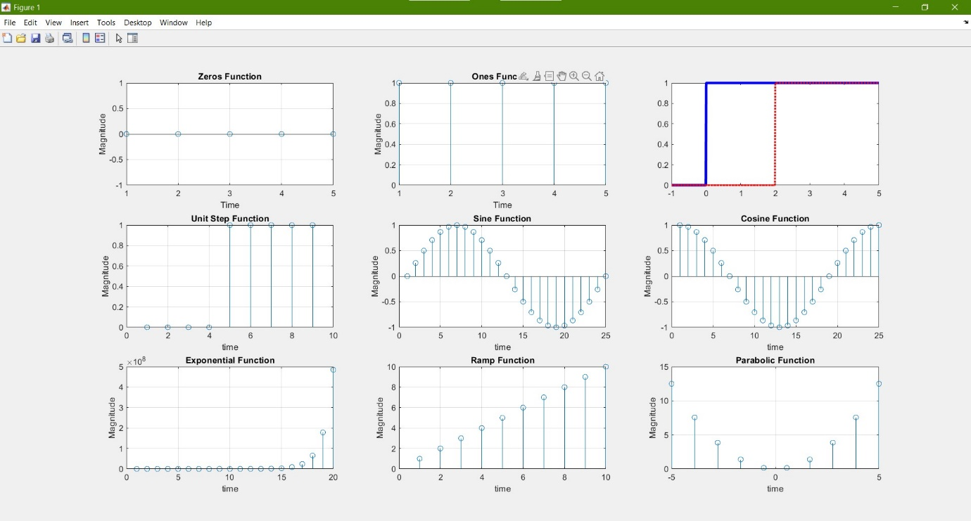

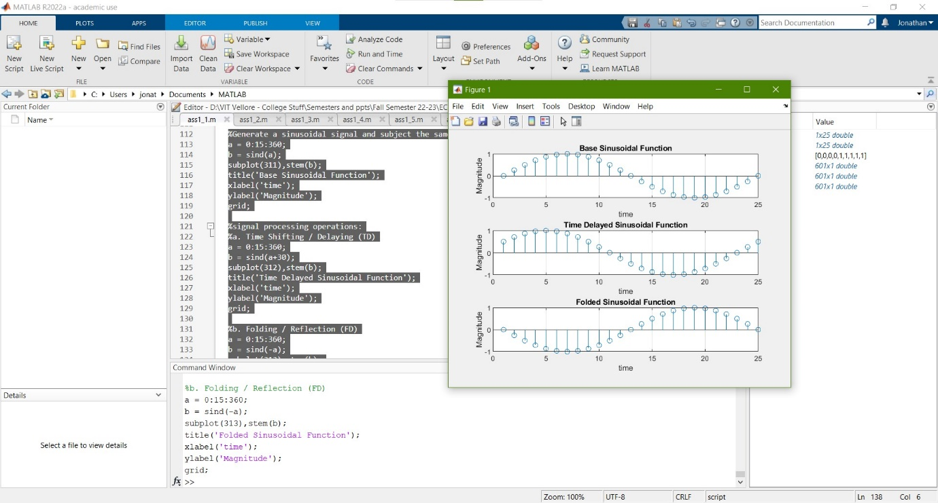

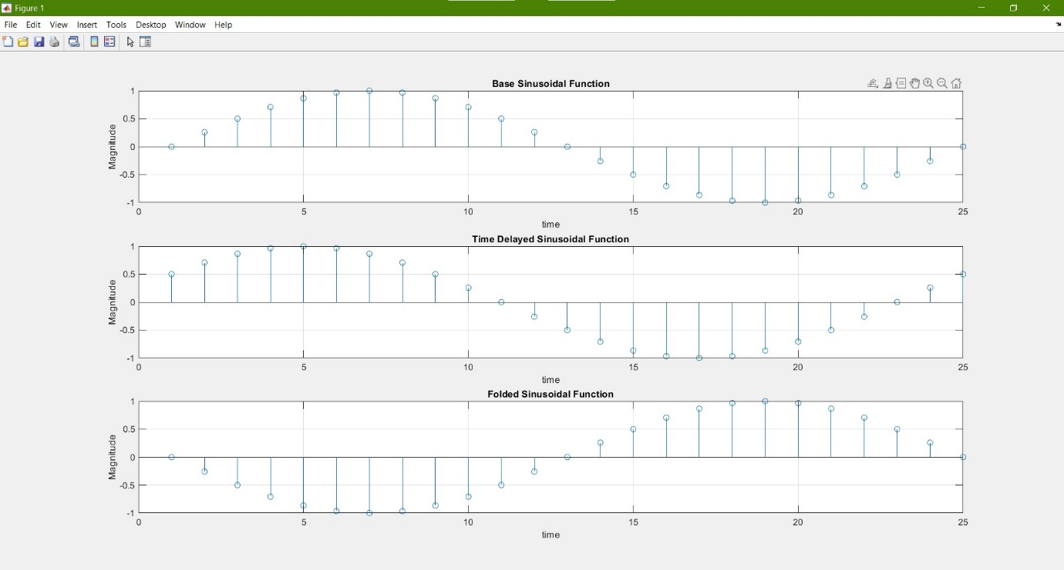

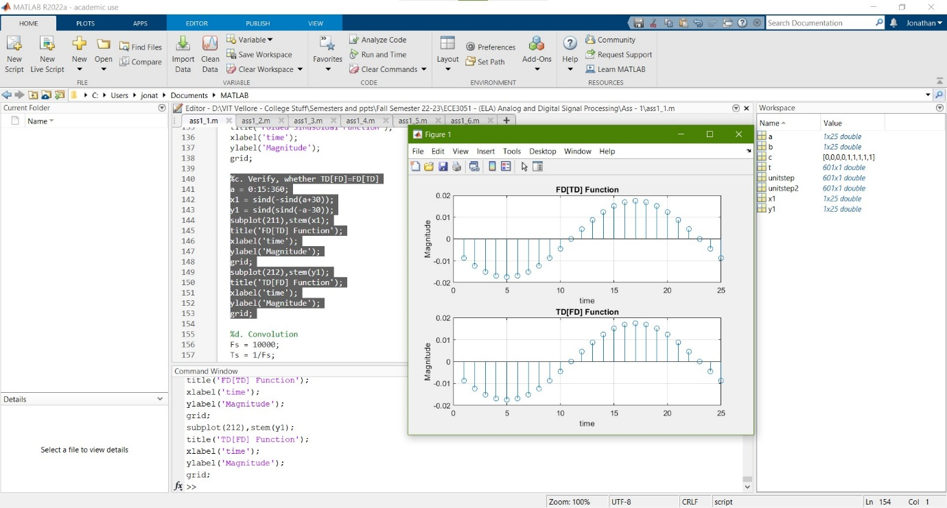

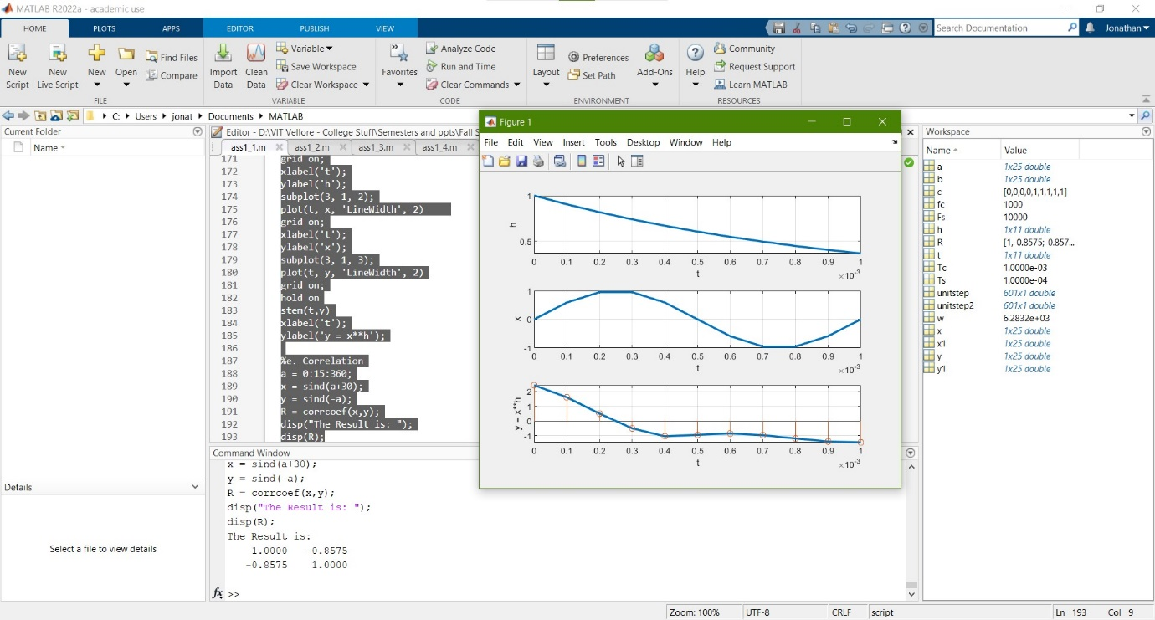

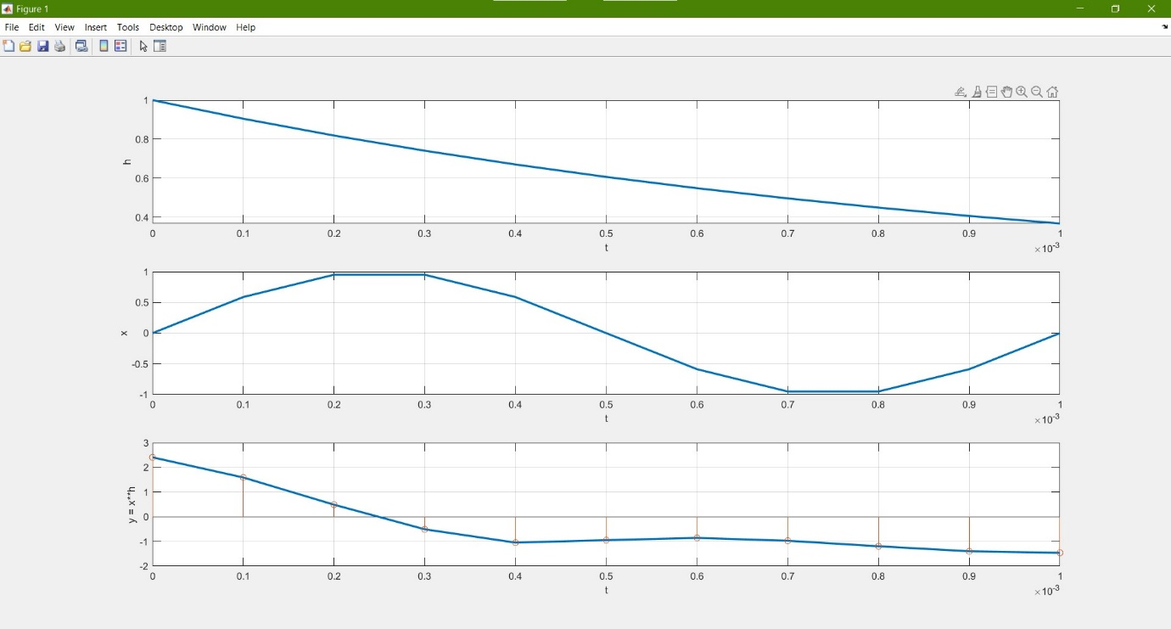

**Q2)** Also, graphically verify whether the following system is linear / non-linear, Stable / unstable: 𝒚(𝒏) = 𝒚 𝟐 (𝒏 − 𝟏) + 𝒙(𝒏), for the bounded input 𝒙(𝒏) = 𝒖(𝒏) + 𝒖(𝒏 − 𝟐)

**CODE:**

%SubTask 2 - graphically verify whether the following system is linear / non-linear,

% Stable /unstable:

% 𝒚(𝒏) = 𝒚^2 (𝒏 − 𝟏) + 𝒙(𝒏), for the bounded input 𝒙(𝒏) = 𝒖(𝒏) + 𝒖(𝒏 − 𝟐)

n0 = -5:5; %range

syms x(n);

x(n) = heaviside(n)-heaviside(n-2);

syms y(n);

y(n) = ((n-1))^2 + x(n);

subplot(111),plot(y(n0),n0);

title('Sequence #1 - Stem');

xlabel('x(n)');

ylabel('n0');

%1) Condition for Linearity: Relationship between x & y is linear (straight

%line), and should cross the origin.

%Answer: NO, it is not Linear, as it does not pass through origin and does

%not satisfy superposition.

%2) Condition for Stability: Should Satisfy the BIBO stability condition.

B = isstable(y);

disp(B);

**OUTPUT:**

>> %SubTask 2 - graphically verify whether the following system is linear / non-linear,

% Stable /unstable:

% 𝒚(𝒏) = 𝒚^2 (𝒏 − 𝟏) + 𝒙(𝒏), for the bounded input 𝒙(𝒏) = 𝒖(𝒏) + 𝒖(𝒏 − 𝟐)

n0 = -5:5; %range

syms x(n);

x(n) = heaviside(n)-heaviside(n-2);

syms y(n);

y(n) = ((n-1))^2 + x(n);

subplot(111),plot(y(n0),n0);

title('Sequence #1 - Stem');

xlabel('x(n)');

ylabel('n0');

%1) Condition for Linearity: Relationship between x & y is linear (straight

%line), and should cross the origin.

%Answer: NO, it is not Linear, as it does not pass through origin and does

%not satisfy superposition.

%2) Condition for Stability: Should Satisfy the BIBO stability condition.

B = isstable(y);

disp(B);

1

>>

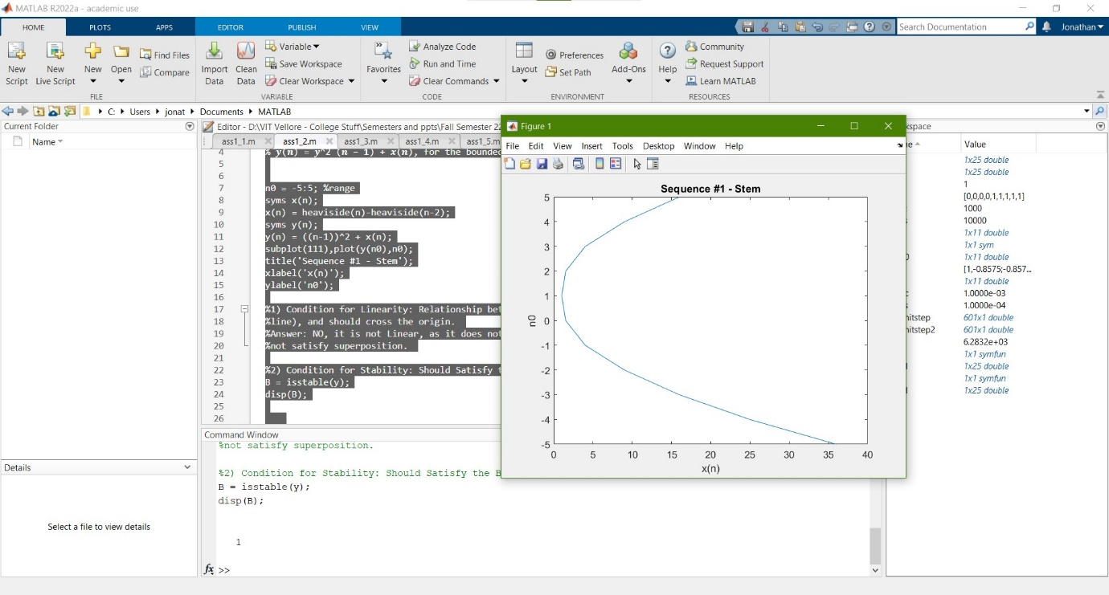

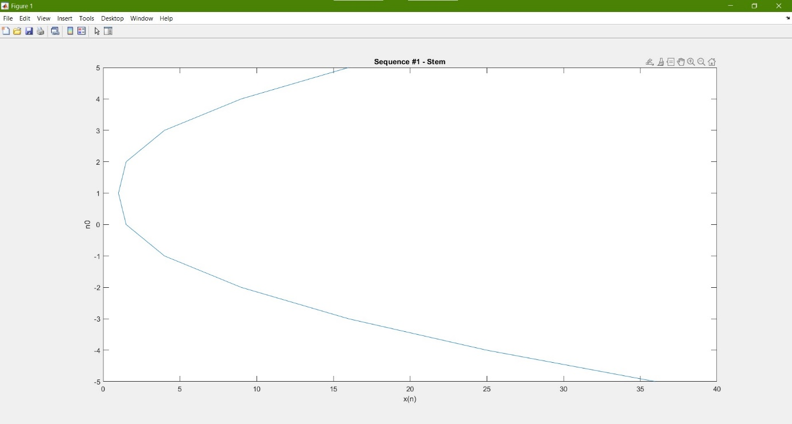

**Q3) Generate and plot each of the following sequences over the indicated interval.**

**a) x(n) = 2delta(n+2) - delta(n-4), -5<=n<=5**

**b) x(n) = n[u(n)-u(n-10)] + 10e^-0.3(n-10) [u(n-10) - u(n-20)]**

**c) x(n) = cos(0.04pi*n) + 0.2 * w(n), 0<=n<=50, where w(n) is a Gaussian Random Sequence with zero limit and unit variance.**

**CODE:**

%SubTask 3 - Generate and plot each of the following sequences over the indicated interval.

%a) x(n) = 2delta(n+2) - delta(n-4), -5<=n<=5

n0 = -5:5; %range

syms x(n);

x(n) = 2*dirac(n+2) - dirac(n-4);

subplot(321),stem(x(n0),n0);

title('Sequence #1 - Stem');

xlabel('x(n)');

ylabel('n0');

subplot(322),plot(x(n0),n0);

title('Sequence #1');

xlabel('x(n)');

ylabel('n0');

grid;

%b) x(n) = n[u(n)-u(n-10)] + 10e^-0.3(n-10) [u(n-10) - u(n-20)]

n0 = -20:20; %range

syms x(n);

x(n) = n*(heaviside(n)-heaviside(n-10)) + (10*exp(-0.3*(n-10)) * (heaviside(n-10) - heaviside(n-20)));

subplot(323),stem(x(n0),n0);

title('Sequence #2 - Stem');

xlabel('x(n)');

ylabel('n0');

subplot(324),plot(x(n0),n0);

title('Sequence #2');

xlabel('x(n)');

ylabel('n0');

grid;

%c) x(n) = cos(0.04pi*n) + 0.2 * w(n), 0<=n<=50, where w(n) is a Gaussian

%Random Sequence with zero limit and unit variance.

n0 = 0:50; %range

syms x(n);

x(n) = cos(0.04*pi*n) + 0.2*normrnd(0,50);%normrnd(n);

subplot(325),stem(x(n0),n0);

title('Sequence #3 - Stem');

xlabel('x(n)');

ylabel('n0');

subplot(326),plot(x(n0),n0);

title('Sequence #3');

xlabel('x(n)');

ylabel('n0');

grid;

**OUTPUT:**

>> %SubTask 3 - Generate and plot each of the following sequences over the indicated interval.

%a) x(n) = 2delta(n+2) - delta(n-4), -5<=n<=5

n0 = -5:5; %range

syms x(n);

x(n) = 2*dirac(n+2) - dirac(n-4);

subplot(321),stem(x(n0),n0);

title('Sequence #1 - Stem');

xlabel('x(n)');

ylabel('n0');

subplot(322),plot(x(n0),n0);

title('Sequence #1');

xlabel('x(n)');

ylabel('n0');

grid;

%b) x(n) = n[u(n)-u(n-10)] + 10e^-0.3(n-10) [u(n-10) - u(n-20)]

n0 = -20:20; %range

syms x(n);

x(n) = n*(heaviside(n)-heaviside(n-10)) + (10*exp(-0.3*(n-10)) * (heaviside(n-10) - heaviside(n-20)));

subplot(323),stem(x(n0),n0);

title('Sequence #2 - Stem');

xlabel('x(n)');

ylabel('n0');

subplot(324),plot(x(n0),n0);

title('Sequence #2');

xlabel('x(n)');

ylabel('n0');

grid;

%c) x(n) = cos(0.04pi*n) + 0.2 * w(n), 0<=n<=50, where w(n) is a Gaussian

%Random Sequence with zero limit and unit variance.

n0 = 0:50; %range

syms x(n);

x(n) = cos(0.04*pi*n) + 0.2*normrnd(0,50);%normrnd(n);

subplot(325),stem(x(n0),n0);

title('Sequence #3 - Stem');

xlabel('x(n)');

ylabel('n0');

subplot(326),plot(x(n0),n0);

title('Sequence #3');

xlabel('x(n)');

ylabel('n0');

grid;

>>

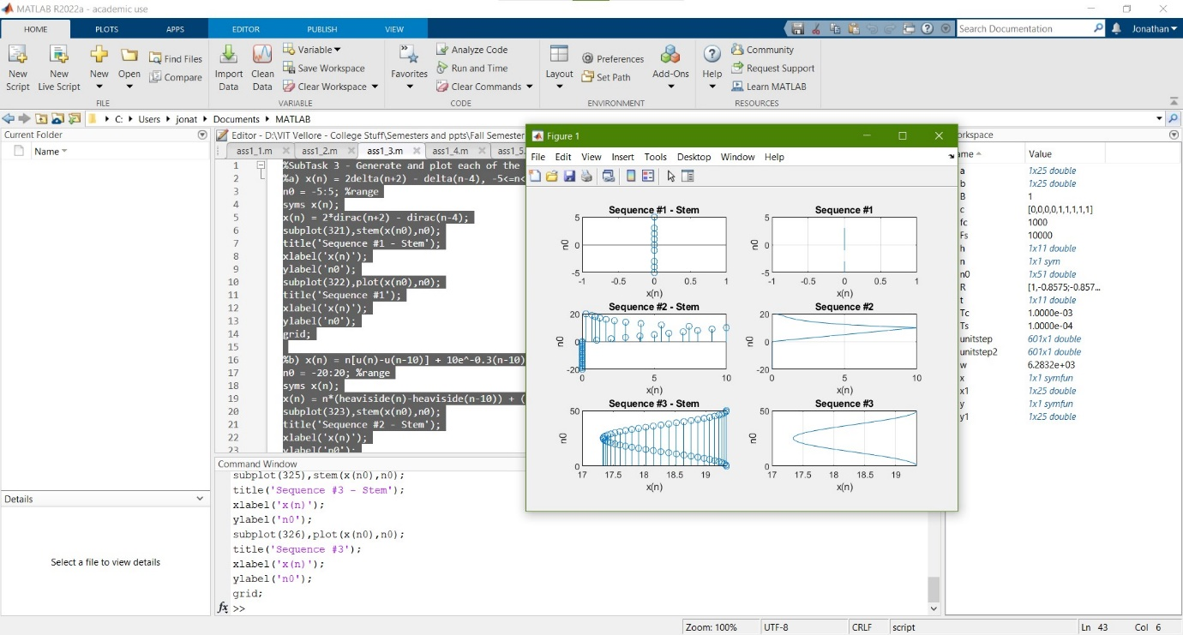

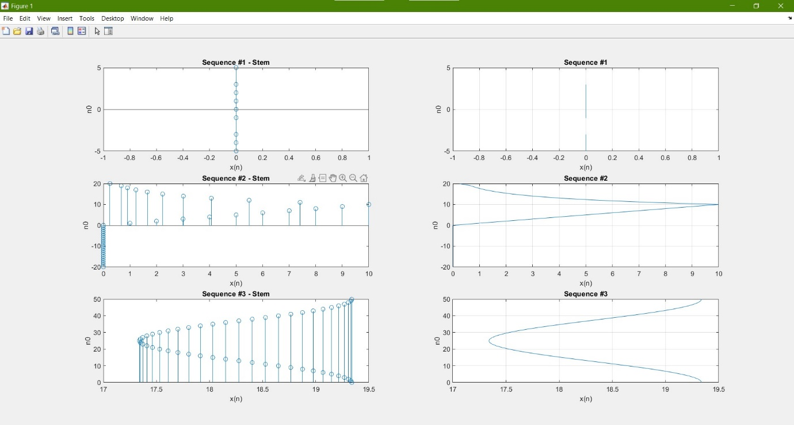

**Q4) Given the following difference equation:**

**y(n) - y(n-1) + 0.9y(n-2) = x(n); for all n**

**a) Calculate and plot the impulse response h(n) at n = -20,. . . ,100.**

**b) Calculate and plot the unit step response s(n) at n = -20, ....., 100.**

**c) Is the system specified by h(n) stable?**

**CODE:**

%Given the following difference equation:

% y(n) - y(n-1) + 0.9y(n-2) = x(n); for all n

%Therefore: We need to use the filter function

%Let us take coefficients of both y (here a) and x (here b)

a = [1 -1 9/10];

b = 1;

y = -20:100;

x = filter(a,b,y);

subplot(321),plot(x,y);

title('Difference Equation of following equation');

xlabel('x');

ylabel('y');

subplot(322),stem(x,y);

title('Difference Equation of following equation');

xlabel('x');

ylabel('y');

% a) Calculate and plot the impulse response h(n) at n = -20,. . . ,100.

subplot(323),plot(dirac(x));

title('impulse response h(n) at n = -20,. . . ,100.');

xlabel('x');

ylabel('y');

subplot(324),stem(dirac(x));

title('impulse response h(n) at n = -20,. . . ,100.');

xlabel('x');

ylabel('y');

% b) Calculate and plot the unit step response s(n) at n = -20, ....., 100.

subplot(325),plot(heaviside(x));

title('unit step response s(n) at n = -20,. . . ,100.');

xlabel('x');

ylabel('y');

subplot(326),stem(heaviside(x));

title('unit step response s(n) at n = -20,. . . ,100.');

xlabel('x');

ylabel('y');

% c) Is the system specified by h(n) stable?

B = isstable(dirac(x));

disp(B);

**OUTPUT:**

>> %Given the following difference equation:

% y(n) - y(n-1) + 0.9y(n-2) = x(n); for all n

%Therefore: We need to use the filter function

%Let us take coefficients of both y (here a) and x (here b)

a = [1 -1 9/10];

b = 1;

y = -20:100;

x = filter(a,b,y);

subplot(321),plot(x,y);

title('Difference Equation of following equation');

xlabel('x');

ylabel('y');

subplot(322),stem(x,y);

title('Difference Equation of following equation');

xlabel('x');

ylabel('y');

% a) Calculate and plot the impulse response h(n) at n = -20,. . . ,100.

subplot(323),plot(dirac(x));

title('impulse response h(n) at n = -20,. . . ,100.');

xlabel('x');

ylabel('y');

subplot(324),stem(dirac(x));

title('impulse response h(n) at n = -20,. . . ,100.');

xlabel('x');

ylabel('y');

% b) Calculate and plot the unit step response s(n) at n = -20, ....., 100.

subplot(325),plot(heaviside(x));

title('unit step response s(n) at n = -20,. . . ,100.');

xlabel('x');

ylabel('y');

subplot(326),stem(heaviside(x));

title('unit step response s(n) at n = -20,. . . ,100.');

xlabel('x');

ylabel('y');

% c) Is the system specified by h(n) stable?

B = isstable(dirac(x));

disp(B);

1

>>

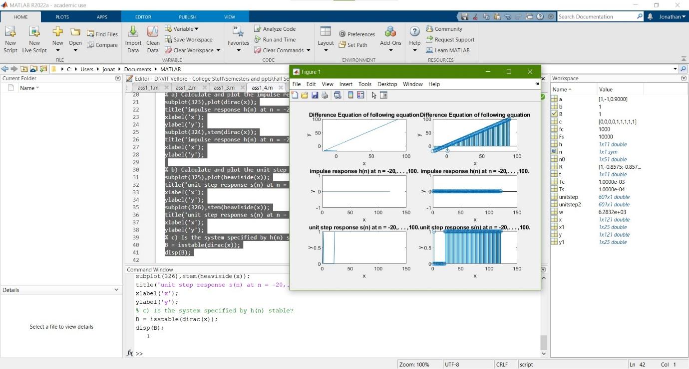

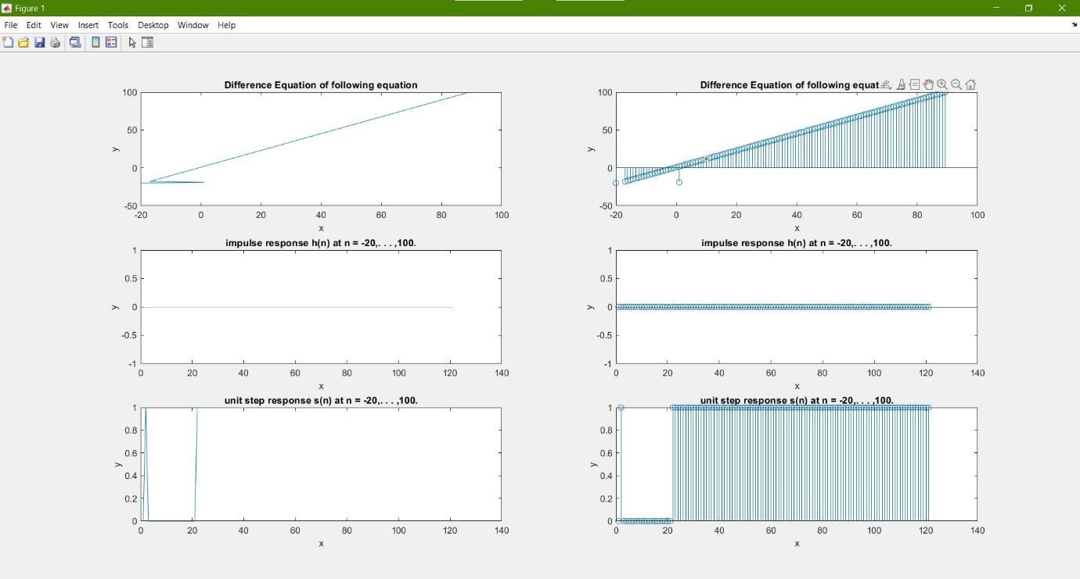

**Q5) A particular linear and time-invariant system is described by the difference equation:**

**y(n) - 0.5y(n-1) + 0.25y(n-2) = x(n) + 2x(n-1) + x(n-3)**

1. **Determine the stability of the system.**
2. **Determine and plot the impulse response of the system over 0<=n<=100.**
3. **Determine the stability from this impulse response**

**CODE:**

%A particular linear and time-invariant system is described by the

%difference equation:

% y(n) - 0.5y(n-1) + 0.25y(n-2) = x(n) + 2x(n-1) + x(n-3)

% a) Determine the stability of the system.

%Therefore: We need to use the filter function

%Let us take coefficients of both y (here a) and x (here b)

a = [1 -5/10 25/100];

b = [1 2 1];

y = 0:100;

x = filter(a,b,y);

subplot(211),plot(x,y);

title('Difference Equation of following equation');

xlabel('x');

ylabel('y');

B = isstable(x);

disp(B);

% b) Determine and plot the impulse response of the system over 0<=n<=100.

z = dirac(x);

subplot(212),stem(z,y);

title('Impulse Response of Difference Equation of following equation');

xlabel('z');

ylabel('y');

% c) Determine the stability from this impulse response

B2 = isstable(z);

disp(B2);

**OUTPUT:**

>> %A particular linear and time-invariant system is described by the

%difference equation:

% y(n) - 0.5y(n-1) + 0.25y(n-2) = x(n) + 2x(n-1) + x(n-3)

% a) Determine the stability of the system.

%Therefore: We need to use the filter function

%Let us take coefficients of both y (here a) and x (here b)

a = [1 -5/10 25/100];

b = [1 2 1];

y = 0:100;

x = filter(a,b,y);

subplot(211),plot(x,y);

title('Difference Equation of following equation');

xlabel('x');

ylabel('y');

B = isstable(x);

disp(B);

% b) Determine and plot the impulse response of the system over 0<=n<=100.

z = dirac(x);

subplot(212),stem(z,y);

title('Impulse Response of Difference Equation of following equation');

xlabel('z');

ylabel('y');

% c) Determine the stability from this impulse response

B2 = isstable(z);

disp(B2);

1

1

>>

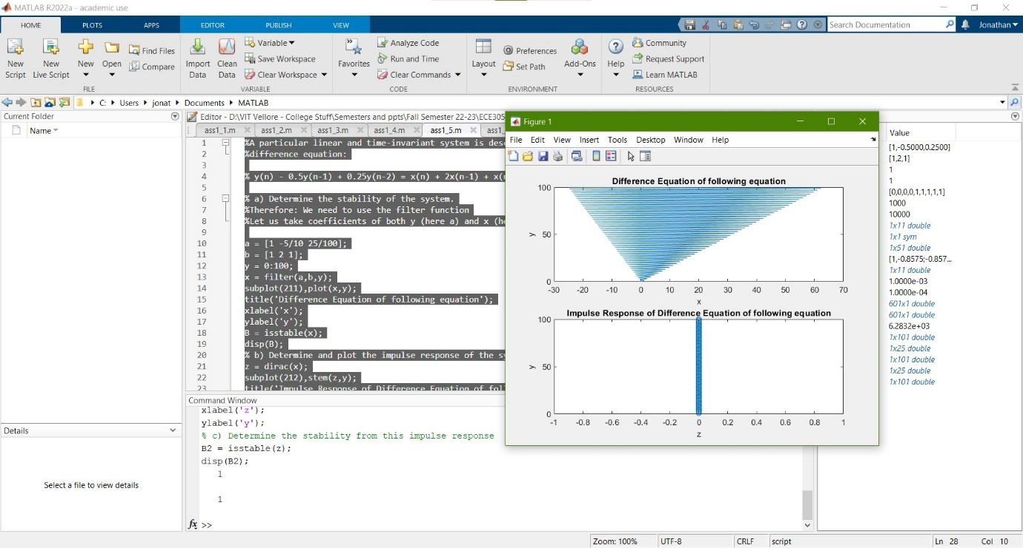

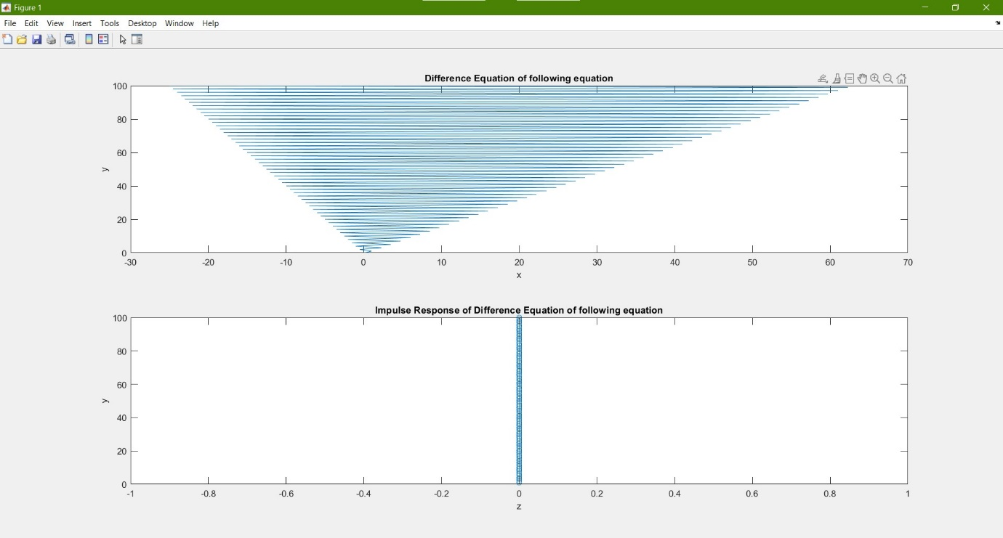

**Q6) A simple digital differentiator is given by:**

**y(n) = x(n) - x(n-1)**

**which computes a backward first-order difference in the input sequence. Implement this differentiator on the following sequences and plot the results. Comment on the appropriateness of this simple differentiator.**

1. **x(n) = 5[u(n)-u(n-20)]: a rectangular pose**
2. **x(n) = n[u(n) - u(n-10)] + (20-n)[u(n-10)-u(n-20)]: a triangular pose.**
3. **x(n) = sin(pi*n/25) * [u(n) - u(n-100)]: a sinusoidal pulse**

**CODE:**

% A simple digital differentitator is given by:

% y(n) = x(n) - x(n-1)

% which computes a backward first-order difference in the input sequence.

% Implement this differentiator on the following sequences and plot the

% results. Comment on the appropriateness of this simple differentiator.

syms y(n);

n0 = 1:5;

% a) x(n) = 5[u(n)-u(n-20)]: a rectangular pose

syms x(n);

x(n) = 5*heaviside(n)-heaviside(n-20);

y(n) = x(n) - x(n-1);

subplot(321),stem(y(n0),n0);

title('Rectangular Pose - Stem');

xlabel('y(n)');

ylabel('n');

subplot(322),plot(y(n0),n0);

title('Rectangular Pose - Plot');

xlabel('y(n)');

ylabel('n');

% b) x(n) = n[u(n) - u(n-10)] + (20-n)[u(n-10)-u(n-20)]: a triangular pose.

x(n) = n*(heaviside(n)-heaviside(n-10)) + ((20-n)*(heaviside(n-10) - heaviside(n-20)));

y(n) = x(n) - x(n-1);

subplot(323),stem(y(n0),n0);

title('Triangular Pose - Stem');

xlabel('y(n)');

ylabel('n');

subplot(324),plot(y(n0),n0);

title('Triangular Pose - Plot');

xlabel('y(n)');

ylabel('n');

% c) x(n) = sin(pi*n/25) * [u(n) - u(n-100)]: a sinusoidal pulse

x(n) = sin((pi*n)/25) * (heaviside(n) - heaviside(n-100));

y(n) = x(n) - x(n-1);

subplot(325),stem(y(n0),n0);

title('Sinusoidal Pose - Stem');

xlabel('y(n)');

ylabel('n');

subplot(326),plot(y(n0),n0);

title('Sinusoidal Pose - Plot');

xlabel('y(n)');

ylabel('n');

**OUTPUT:**

>> % A simple digital differentitator is given by:

% y(n) = x(n) - x(n-1)

% which computes a backward first-order difference in the input sequence.

% Implement this differentiator on the following sequences and plot the

% results. Comment on the appropriateness of this simple differentiator.

syms y(n);

n0 = 1:5;

% a) x(n) = 5[u(n)-u(n-20)]: a rectangular pose

syms x(n);

x(n) = 5*heaviside(n)-heaviside(n-20);

y(n) = x(n) - x(n-1);

subplot(321),stem(y(n0),n0);

title('Rectangular Pose - Stem');

xlabel('y(n)');

ylabel('n');

subplot(322),plot(y(n0),n0);

title('Rectangular Pose - Plot');

xlabel('y(n)');

ylabel('n');

% b) x(n) = n[u(n) - u(n-10)] + (20-n)[u(n-10)-u(n-20)]: a triangular pose.

x(n) = n*(heaviside(n)-heaviside(n-10)) + ((20-n)*(heaviside(n-10) - heaviside(n-20)));

y(n) = x(n) - x(n-1);

subplot(323),stem(y(n0),n0);

title('Triangular Pose - Stem');

xlabel('y(n)');

ylabel('n');

subplot(324),plot(y(n0),n0);

title('Triangular Pose - Plot');

xlabel('y(n)');

ylabel('n');

% c) x(n) = sin(pi*n/25) * [u(n) - u(n-100)]: a sinusoidal pulse

x(n) = sin((pi*n)/25) * (heaviside(n) - heaviside(n-100));

y(n) = x(n) - x(n-1);

subplot(325),stem(y(n0),n0);

title('Sinusoidal Pose - Stem');

xlabel('y(n)');

ylabel('n');

subplot(326),plot(y(n0),n0);

title('Sinusoidal Pose - Plot');

xlabel('y(n)');

ylabel('n');

>>



